SB STOCKS
A Paper Trading Simulation Platform (MERN Stack)
Final Project Report
Submitted as part of project completion requirements

Table of Contents
1. Introduction
1.1 Project Overview
1.2 Purpose
2. Ideation Phase
2.1 Problem Statement
2.2 Empathy Map Canvas
2.3 Brainstorming
3. Requirement Analysis
3.1 Customer Journey Map
3.2 Solution Requirement
3.3 Data Flow Diagram
3.4 Technology Stack
4. Project Design
4.1 Problem Solution Fit
4.2 Proposed Solution
4.3 Solution Architecture
5. Project Planning & Scheduling
5.1 Project Planning
6. Functional and Performance Testing
6.1 Performance Testing
7. Results
7.1 Output Screenshots
8. Advantages & Disadvantages
9. Conclusion
10. Future Scope
11. Appendix

1. Introduction

1.1 Project Overview
SB Stocks is a full-stack, MERN-based (MongoDB, Express.js, React.js, Node.js) stock trading simulation web application designed for stock market enthusiasts who want to practice and improve their trading skills without any financial risk. The platform offers paper trading powered by real-time US stock market data, historical price trends, and a wide range of stock listings, enabling users to make informed, data-driven trading decisions.
Through a simple registration and secure login process, users gain access to a personalized dashboard where they can simulate the buying and selling of stocks using virtual funds, create and manage multiple portfolios, track portfolio performance, and analyze the outcomes of different trading strategies in a realistic, risk-free environment. An administrative layer allows platform administrators to oversee users, transactions, and stock data, ensuring the integrity and reliability of the simulation.
Whether the user is a beginner exploring the fundamentals of trading or an experienced trader testing new strategies, SB Stocks combines a clean, intuitive interface with comprehensive market data and robust portfolio management tools to deliver an engaging and educational trading experience.

1.2 Purpose
The purpose of SB Stocks is to bridge the gap between theoretical trading knowledge and practical experience by giving users a safe, risk-free environment to learn and refine stock trading strategies. Specifically, the platform aims to:
- Enable users to practice buying and selling US-listed stocks using virtual funds instead of real money.
- Provide real-time market data and historical trends so that trading decisions are grounded in realistic market conditions.
- Help users build and track multiple virtual portfolios to understand diversification and portfolio management.
- Maintain a transparent transaction history so users can review and learn from their past trading decisions.
- Give administrators the tools to monitor platform activity, maintain stock/market data accuracy, and ensure a fair, secure simulation environment for all users.
- Build user confidence and competence in trading concepts before they risk actual capital in real markets.

2. Ideation Phase

2.1 Problem Statement
"Beginner and intermediate stock market enthusiasts do not have an easy, risk-free way to practice real trading strategies using live market data — most either risk real capital while still learning or rely on static tutorials/simulators that don't reflect real market behavior. This lack of a realistic, low-risk practice environment slows down skill-building and discourages new traders from confidently entering the stock market."
This problem affects a wide audience: students learning about financial markets, working professionals wanting to invest but hesitant due to inexperience, and even experienced traders who want to backtest new strategies without financial exposure.

2.2 Empathy Map Canvas
An empathy map was created around the persona 'Sophia', a finance enthusiast who wants to learn stock trading without financial risk, to better understand user needs, pain points, and motivations.
Category | Details
SAYS | "I want to learn trading, but I can't afford to lose real money while I'm still learning." "I wish I could test my strategy before using it for real." "I need up-to-date stock prices to make this feel real."
THINKS | "What if I make a mistake and lose everything?" "Is there a simple way to track how well my strategy is performing?" "I want an app that feels like real trading, not just a game."
DOES | Watches trading tutorials online, reads finance blogs, tracks stock prices manually on spreadsheets, hesitates to open a real brokerage account.
FEELS | Curious and motivated to learn, but anxious about financial risk; frustrated by the lack of realistic practice tools; excited when she sees measurable progress in her (virtual) portfolio.
PAINS | Fear of financial loss, information overload from scattered resources, lack of a single platform combining real data with risk-free practice.
GAINS | Confidence in trading decisions, a clear track record of strategy performance, hands-on understanding of market behavior, readiness to eventually invest real capital.

2.3 Brainstorming
Based on the problem statement and empathy map, the team brainstormed the following ideas, which were then prioritized and grouped into the final feature set of SB Stocks:
- Provide virtual/paper money to each user on registration so trades carry no real financial risk.
- Integrate a real-time stock market data feed for accurate, live pricing during simulated trades.
- Allow users to view historical stock trends and charts to support informed decision-making.
- Let users create and manage multiple virtual portfolios to practice diversification.
- Maintain a complete transaction log (buy/sell history) so users can review and learn from past decisions.
- Add an admin dashboard to monitor users, transactions, and stock data integrity.
- Keep the UI simple and intuitive so both beginners and experienced traders can use it comfortably.
- Provide portfolio performance metrics (profit/loss, current value) to help users evaluate strategies objectively.
These ideas were consolidated into the core modules of SB Stocks: User Authentication, Stock Listings & Market Data, Paper Trading (Orders), Portfolio & Transaction Management, and an Admin module.

3. Requirement Analysis

3.1 Customer Journey Map
The customer journey map traces a typical user's experience from first discovering SB Stocks to becoming a confident, active simulated trader:
Stage | User Actions & Experience
Awareness | User discovers SB Stocks while looking for a risk-free way to learn stock trading.
Registration | User signs up with personal details and login credentials; receives confirmation and is redirected to login.
Onboarding | User logs in and lands on a personalized dashboard showing virtual funds and available actions.
Exploration | User browses stock listings, filters by industry/sector, and studies real-time prices and historical charts.
Engagement (Trading) | User selects a stock, chooses Buy/Sell, enters quantity, and confirms the order; the transaction is logged and the portfolio updates instantly.
Tracking & Analysis | User monitors portfolio value, profit/loss, and reviews past transactions in the History section.
Retention | User returns regularly to refine strategies, test new stocks, and track long-term portfolio growth.

3.2 Solution Requirement
Functional Requirements:
- User registration and secure login/authentication.
- Personalized user dashboard displaying virtual funds, portfolio summary, and recent activity.
- Browse and search comprehensive US stock listings with real-time prices.
- View historical stock data and price trend charts.
- Execute simulated Buy/Sell orders using virtual funds.
- Create and manage multiple virtual portfolios.
- Maintain a transaction history log with timestamps.
- Admin module to manage users, view all orders/transactions, and monitor stock data.
Non-Functional Requirements:
- Usability: Simple, intuitive UI usable by both beginners and experienced traders.
- Performance: Fast page loads and near real-time updates to stock prices and portfolio values.
- Security: Encrypted password storage and protected/authenticated API routes.
- Scalability: Modular MVC architecture that supports adding new features without major rework.
- Reliability: Consistent and accurate recording of transactions and portfolio updates.
- Availability: The platform should remain accessible with minimal downtime.

3.3 Data Flow Diagram
Level 0 (Context Diagram): The User and Admin are external entities that interact with the SB Stocks system. The User sends registration, login, and trade (buy/sell) requests and receives portfolio, stock, and transaction data in return. The Admin sends monitoring/management requests and receives user, stock, and transaction data.
- User → [Register/Login/Trade Requests] → SB Stocks System → [Dashboard, Portfolio, Stock & Transaction Data] → User
- Admin → [Manage Users/Stocks/View Transactions] → SB Stocks System → [User, Stock, Transaction Reports] → Admin
Level 1 (Detailed DFD): The system is broken down into core processes that map directly to the backend controllers:
- Process 1 – User Management: Handles registration, login, and profile data; reads/writes to the Users data store.
- Process 2 – Stock Management: Fetches and serves real-time and historical stock data; reads/writes to the Stocks data store.
- Process 3 – Order Management: Processes Buy/Sell order requests; reads/writes to the Orders data store and updates the Users' virtual balance.
- Process 4 – Transaction Management: Records every completed trade; reads/writes to the Transactions data store, linked to both Users and Stocks.
- Process 5 – Admin Operations: Reads across Users, Stocks, Orders, and Transactions data stores to provide monitoring and management views.

3.4 Technology Stack
Layer | Technology | Purpose
Frontend | React.js | Building dynamic, responsive user interface components (dashboard, charts, portfolio views).
Frontend Tooling | Vite, npm | Project scaffolding and dependency/package management.
Backend | Node.js, Express.js | Server-side runtime and RESTful API routing/business logic.
Database | MongoDB (Mongoose) | NoSQL storage for users, stocks, orders, and transactions.
Authentication | Custom Auth Middleware | Securing protected routes and managing user sessions.
API Testing | Postman | Testing and validating backend REST APIs during development.
IDE | Visual Studio Code | Primary code editor with integrated Git and terminal support.
Version Control | Git & GitHub | Source code management and collaboration.

4. Project Design

4.1 Problem Solution Fit
Problem: Beginners and enthusiasts lack a realistic, risk-free way to practice stock trading with live market data.
Solution Fit: SB Stocks directly addresses this by combining real-time and historical US stock market data with a virtual-funds trading engine, so users experience authentic market conditions and price movements while trading with zero financial risk. The platform's portfolio tracking and transaction history close the feedback loop, letting users see the real consequences of their strategies (in virtual terms) and iterate — which is exactly the practice-and-feedback cycle identified as the core user need in the empathy map.

4.2 Proposed Solution
Parameter | Description
Problem Statement | Lack of a risk-free, realistic environment for learning and practicing stock trading with live market data.
Idea / Solution | A MERN-based web application (SB Stocks) offering paper trading with virtual funds, real-time and historical stock data, portfolio management, and transaction tracking.
Novelty / Uniqueness | Combines real-time US market data with a fully simulated trading engine and multi-portfolio management, going beyond static tutorials or simple watchlists.
Social Impact / Value | Improves financial literacy and trading confidence, helping users transition safely from learning to real-world investing.
Business / Scalability Model | Can be extended with premium analytics, additional markets, or educational content subscriptions; admin tools support platform growth and monitoring.
Scalability of the Solution | Modular MVC backend and component-based React frontend allow new features (e.g., new markets, strategy tools) to be added with minimal rework.

4.3 Solution Architecture
SB Stocks follows a modular full-stack architecture using the MERN stack, cleanly separating the Frontend (React), Backend (Express + Node.js), and Database (MongoDB) layers:
- Frontend: Built using React, providing the landing page, user home/dashboard, admin dashboard, stock charts, stock order screens, and the user's stock portfolio views.
- Backend: Built using Node.js and Express, exposing API endpoints for Users, Deposits/Withdrawals, Transactions, and Stock Orders, along with Admin Authentication and Admin Dashboard endpoints.
- Database: MongoDB stores collections for Users, Stocks, Orders, and Transactions.
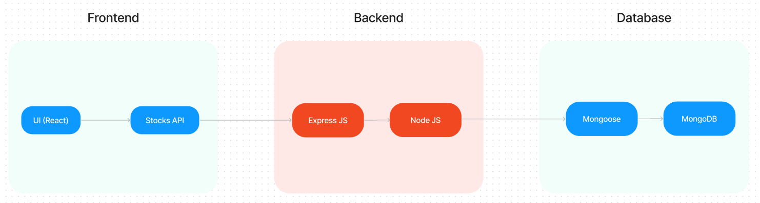
Fig 4.1 – SB Stocks Technical Architecture Diagram
The corresponding ER diagram below shows how the Users, Stocks, Transactions, Portfolios, and Market Data entities relate: a User can create multiple Virtual Portfolios holding many Stocks; each Transaction links a User and a Stock; and Market Data supplies real-time and historical prices used across the system.
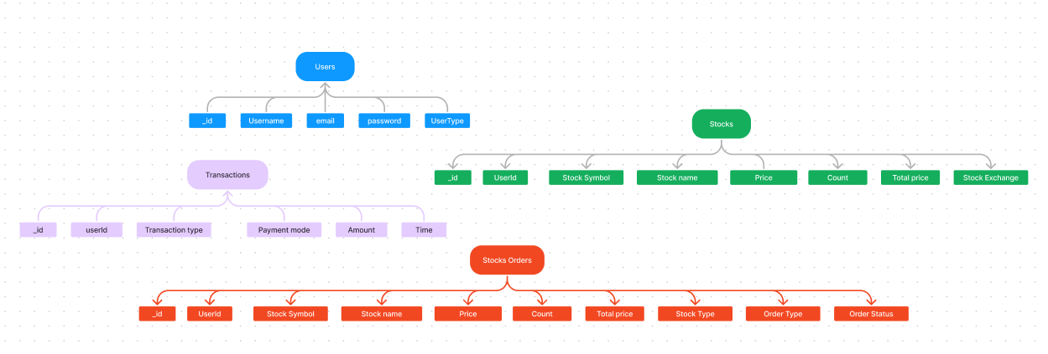
Fig 4.2 – SB Stocks ER Diagram

5. Project Planning & Scheduling

5.1 Project Planning
The project was planned and executed in an iterative, sprint-based manner, moving from setup and core backend/database design through frontend development, integration, and final testing:
Sprint | Functional Requirement (Epic) | Tasks | Story Points
Sprint 1 | Project Setup & Database Design | Set up client/server folders; initialize React (Vite) and Express projects; configure MongoDB connection; design Schemas (User, Stock, Transaction, Order). | 10
Sprint 2 | User Authentication | Implement user registration & login APIs; build authentication middleware; create Register/Login UI components. | 10
Sprint 3 | Stock Listings & Market Data | Build Stock model/controller/routes; integrate real-time & historical stock data; build StockChart and stock listing pages. | 10
Sprint 4 | Paper Trading & Portfolio | Implement Order and Transaction controllers/routes; build Buy/Sell flows; build Portfolio and History pages. | 10
Sprint 5 | Admin Module & Testing | Build Admin dashboard, All Orders/Transactions/Users pages; conduct functional and performance testing; bug fixes and deployment prep. | 10
Each sprint followed a consistent cycle of planning, development, internal review, and testing before moving to the next stage, ensuring incremental delivery of working features.

6. Functional and Performance Testing
Functional Testing: Each module — user registration/login, stock listing, order placement, portfolio updates, transaction history, and admin operations — was tested against its expected behavior using both manual testing in the browser and API testing in Postman. Test cases covered valid/invalid login credentials, successful and failed order placements (e.g., insufficient virtual balance), correct portfolio recalculation after trades, and correct authorization checks on protected admin routes.

6.1 Performance Testing
Performance testing focused on response times and data consistency under typical usage:
Test Parameter | Observation
API Response Time | Core APIs (login, stock listing, order placement) responded within acceptable limits for a smooth user experience during manual and Postman-based load checks.
Real-time Data Updates | Stock price and portfolio value updates reflected promptly after each simulated trade.
Concurrent User Handling | Multiple simulated user sessions (registration, login, trading) were tested to ensure MongoDB and Express handled concurrent requests without data corruption.
Frontend Load Time | React app (served via Vite dev server) loaded key pages such as Dashboard, Stock Chart, and Portfolio quickly on standard hardware/browsers.
Database Query Performance | Mongoose queries for fetching stocks, orders, and transactions were optimized to return results efficiently for typical dataset sizes used in testing.

7. Results

7.1 Output Screenshots
The following screenshots demonstrate the working SB Stocks application across its key screens:
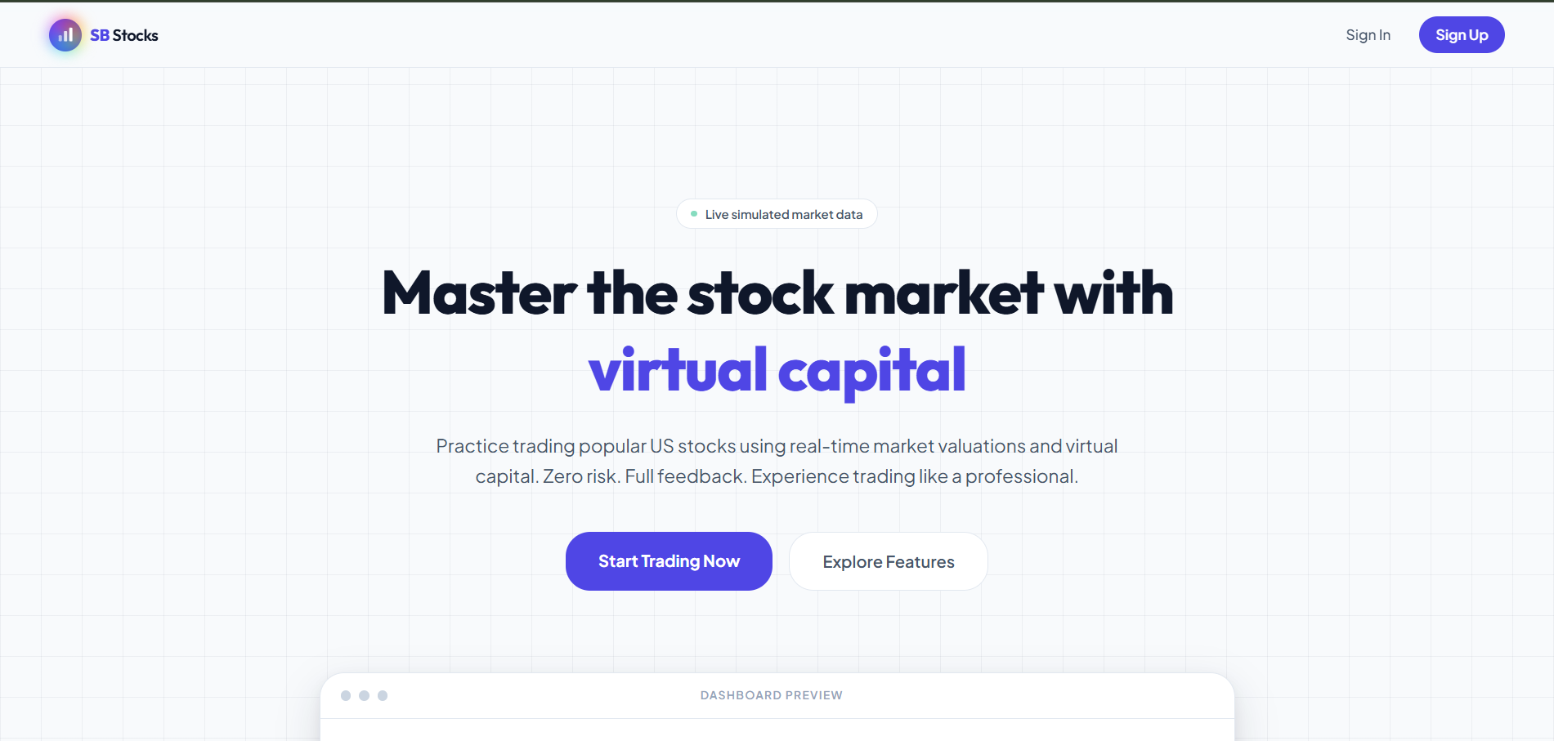
Fig 7.1 – Landing Page
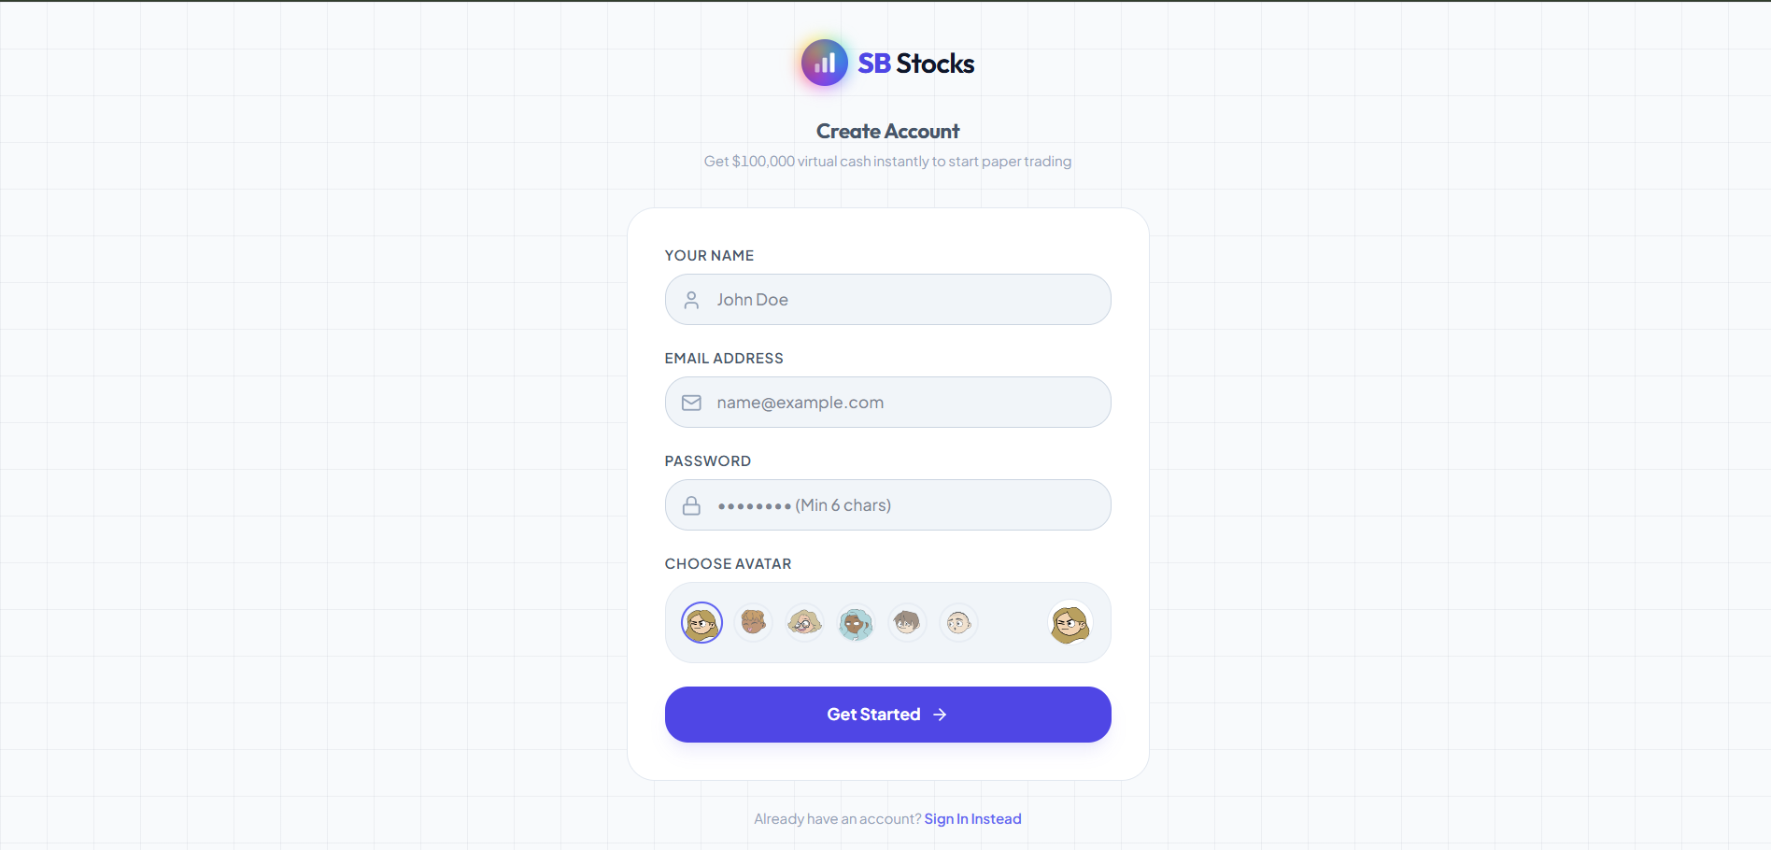
Fig 7.2 – Registration Page
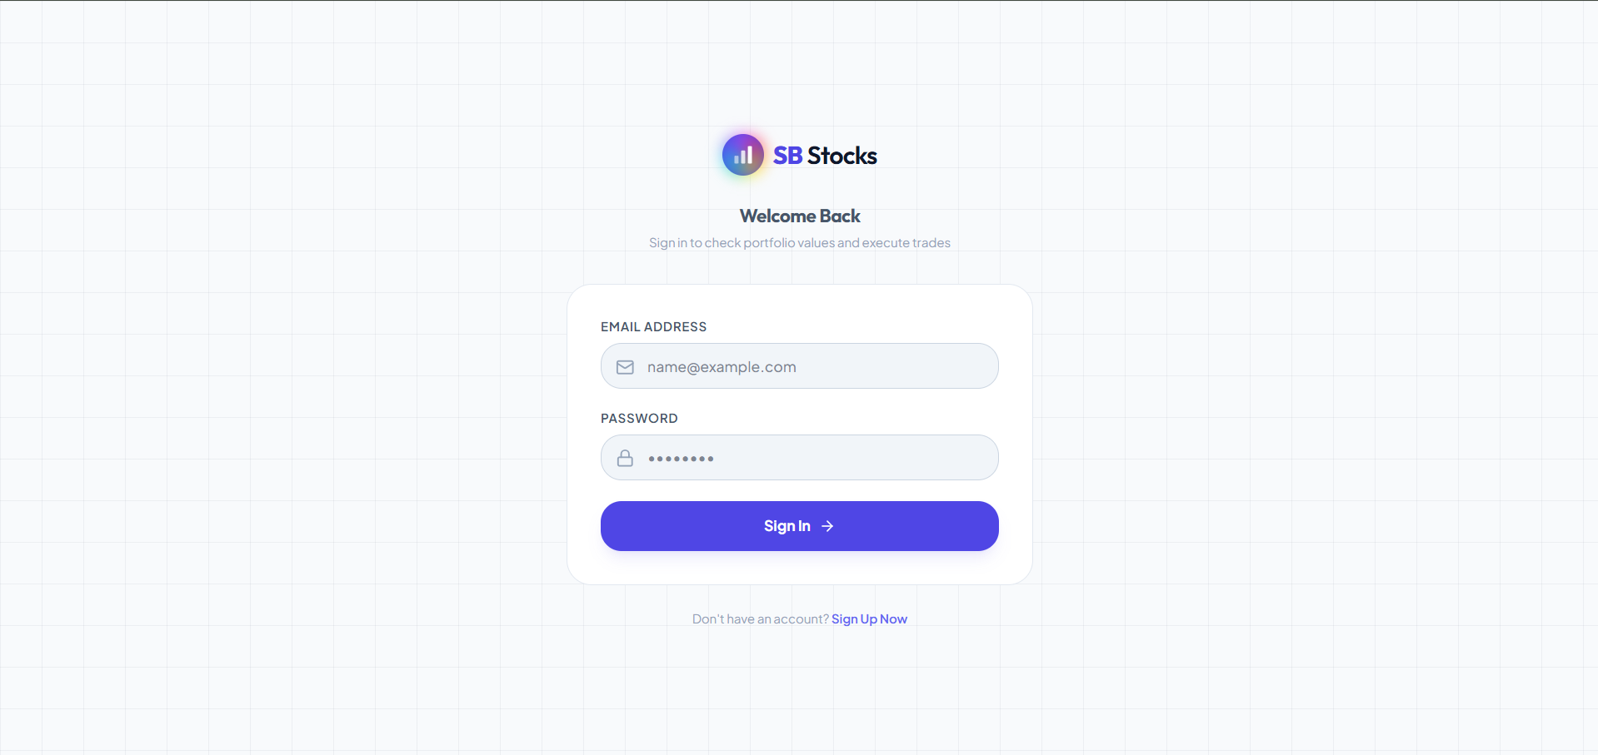
Fig 7.3 – Login Page
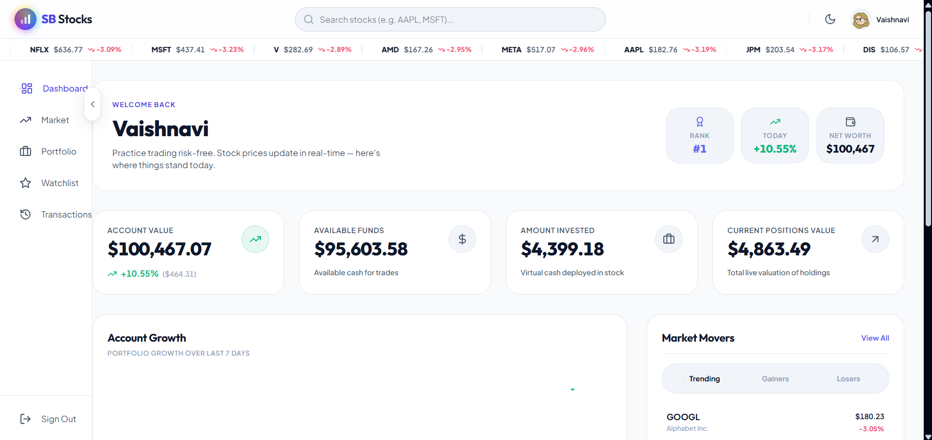
Fig 7.4 – Home Page
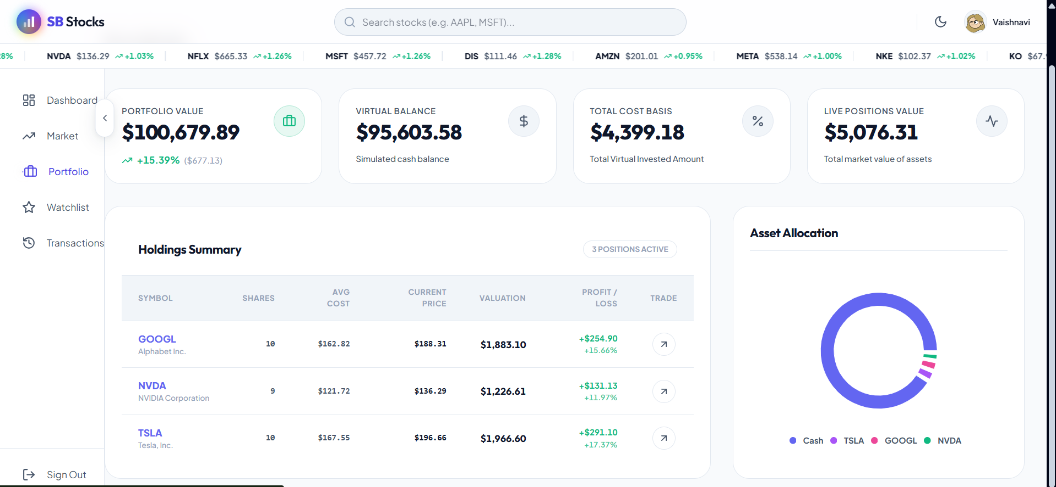
Fig 7.5 – Profile Page (User)
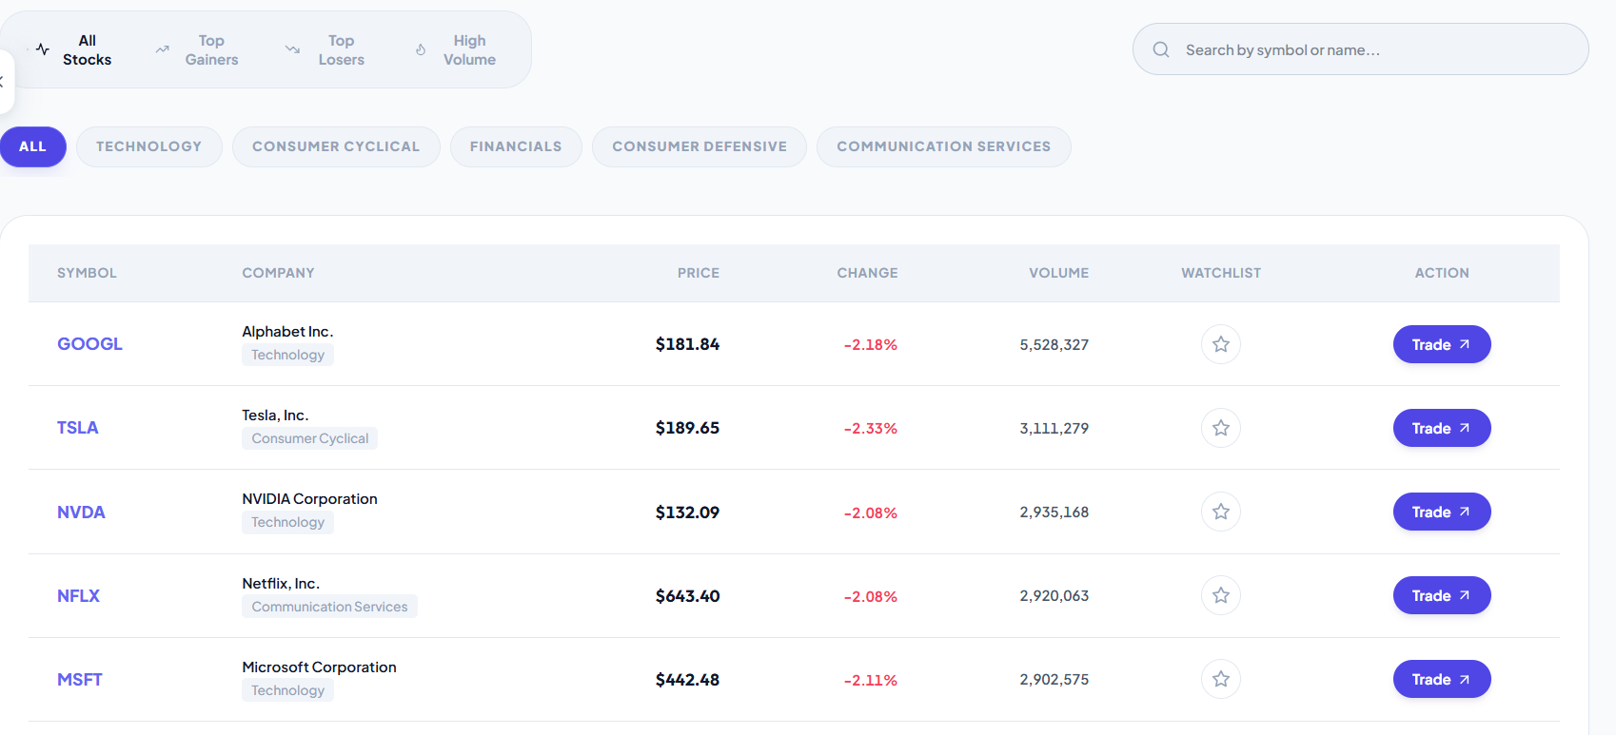
Fig 7.6 – Stock Chart
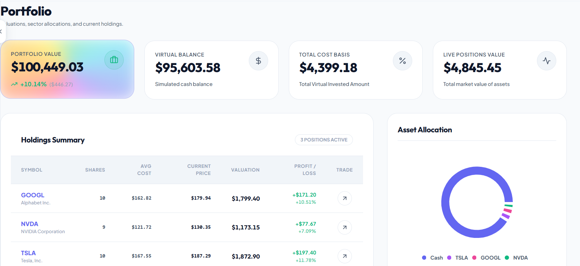
Fig 7.7 – Portfolio
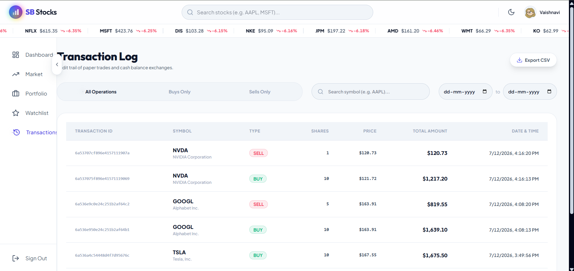
Fig 7.8 – Transaction History
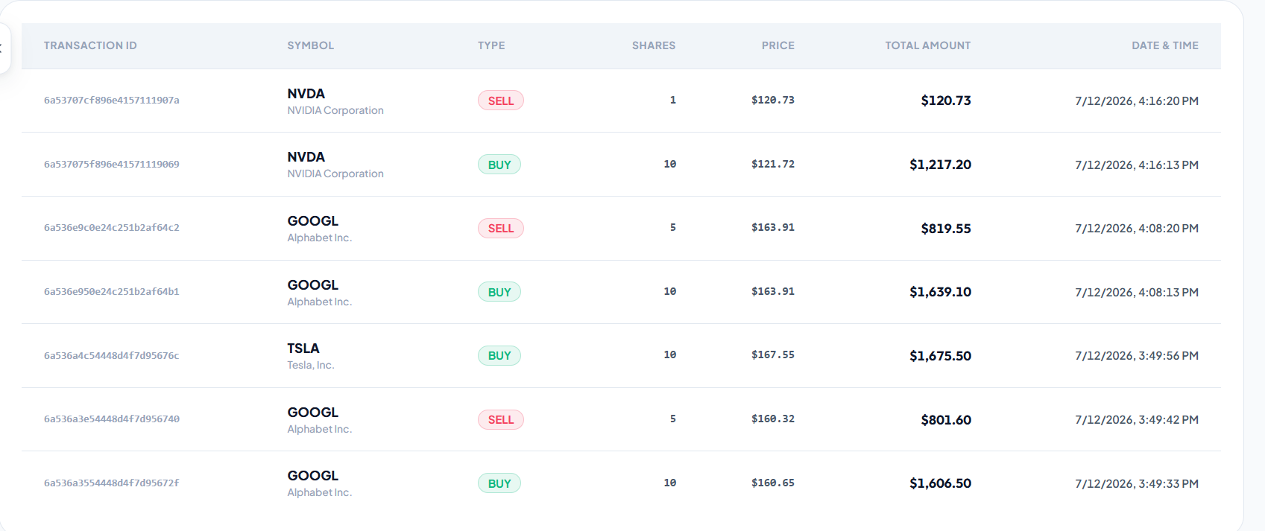
Fig 7.9 – All Transactions (Admin)

8. Advantages & Disadvantages

Advantages
- Allows users to practice stock trading with real market data without any financial risk.
- Provides real-time prices and historical trends for realistic strategy testing.
- Supports multiple virtual portfolios, teaching diversification and portfolio management.
- Maintains a complete transaction history for self-review and learning.
- Clean, modular MVC architecture makes the system easy to maintain and extend.
- Admin module ensures oversight, data accuracy, and platform reliability.
- Simple, intuitive interface suitable for both beginners and experienced traders.

Disadvantages
- Simulated trading with virtual funds cannot fully replicate the psychological pressure of real financial risk.
- Dependent on third-party market data sources; any data feed downtime affects real-time accuracy.
- Currently limited to the US stock market, restricting practice on other global markets.
- Does not yet model real-world trading frictions such as brokerage fees, slippage, or order-execution delays in depth.
- No mobile application yet; the platform is currently accessible only via web browser.

9. Conclusion
SB Stocks successfully delivers a full-stack, risk-free stock trading simulation platform built on the MERN stack. By combining secure user authentication, real-time and historical market data, virtual portfolio management, and detailed transaction tracking, the application gives users a realistic and educational environment to build trading skills and confidence. The modular MVC architecture ensured clean separation between the data, business logic, and presentation layers, making the system maintainable, testable, and straightforward to extend. Overall, the project meets its core objective of helping users — from beginners to experienced traders — practice and refine stock trading strategies without financial risk.

10. Future Scope
- Expand market coverage beyond US stocks to include international exchanges, cryptocurrency, and commodities.
- Introduce advanced analytics such as technical indicators (RSI, MACD, moving averages) for deeper strategy testing.
- Add a leaderboard and community features to let users compare portfolio performance and share strategies.
- Simulate real-world trading frictions like brokerage fees, taxes, and order slippage for even greater realism.
- Develop a mobile application (React Native) for on-the-go trading practice.
- Integrate educational content, tutorials, and guided strategy challenges directly into the platform.
- Add push/email notifications for price alerts, portfolio milestones, and market news.

11. Appendix

Source Code (if any)
GitHub Repository: https://github.com/Vaishnavi736/SB-Stocks
Code Drive Link: https://drive.google.com/drive/folders/1ELLxaLnizTN1-n-7X0E8RWVFQpmzIuo5

Dataset Link
SB Stocks uses a live/real-time US stock market data feed (integrated via the backend Stock module) rather than a static dataset; historical price data used for trend analysis is sourced through the same market data integration referenced in the Stocks schema and stock controller.

GitHub & Project Demo Link
GitHub: https://github.com/Vaishnavi736/SB-Stocks
Project Demo Video: https://drive.google.com/drive/folders/1JiHO0ZJZ-x2k5BXiyH7UKr2WiBQltpeq

